Horizontal Jumps & Sprints

Event Group Development Sessions

Athletics Northern Ireland will provide twice weekly horizontal sprints and jumps development sessions delivered by Commonwealth Games Athlete, Jumps Specialist and International Sprints Coach- Adam McMullen. Beginning in October, sessions for athletes aged 14-19 years old will take place on a Thursday (Mary Peters Track) and Saturday (Ulster University Indoor Track, Jordanstown.)
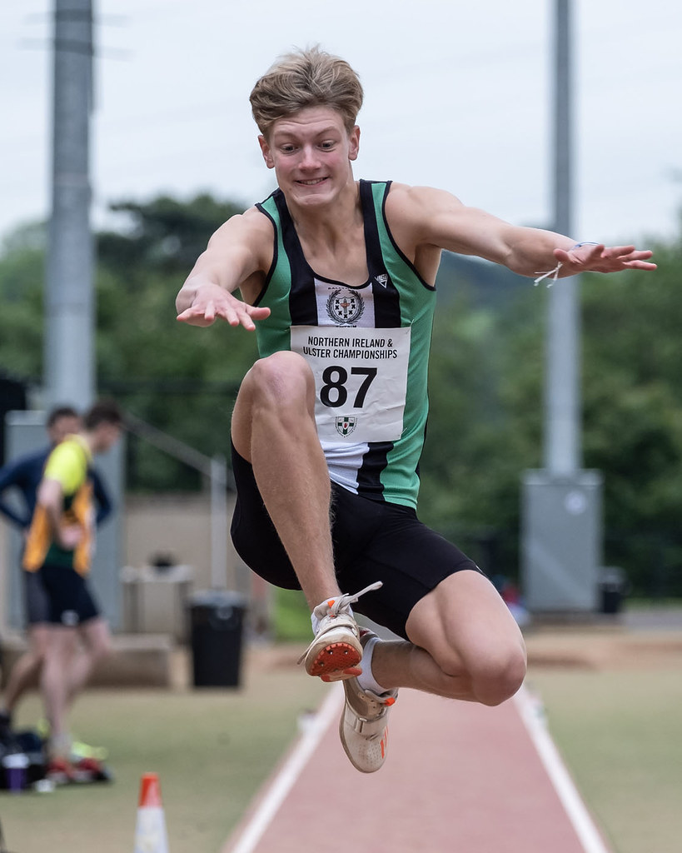

Athletics Northern Ireland aim to provide opportunities for teenage athletes to train and learn together on a regular basis and have upskilled a number of event specialist coaches to support this. Ultimately, we aim to see technically and physically well-prepared athletes progress to Youth Academy and on to represent Northern Ireland as senior athletes.

These sessions aim to bridge the gap to technical event specific training for Rising Stars athletes with multi events experience or schools’ athletes who have some experience and wish to train on a more regular basis for sprinting or Long/Triple Jump.

The training emphasis will develop through the year and sessions for jumpers will include a functional movement based warm up, some form of sprinting either acceleration of max velocity, bounding, short approach jumps and full approach jumps.

Athletes may elect to attend one session per week (£5) or two sessions per week (£8) with a 12 week term running until Christmas. ** If this is a key session for any Academy athlete a fee waiver or discount will be arranged. The session times and format are as follows;

- Thursday 6.30pm- 8.30pm Jumpers arrive at 6.30pm and Sprinters arrive at 7pm at Mary Peters Track Belfast

- Saturday 12pm – 3pm Sprinters arrive at 12pm and Jumpers arrive at 12.30pm with a gym-based Strength & Conditioning session taking place from 2pm – 3pm at Ulster University Jordanstown.
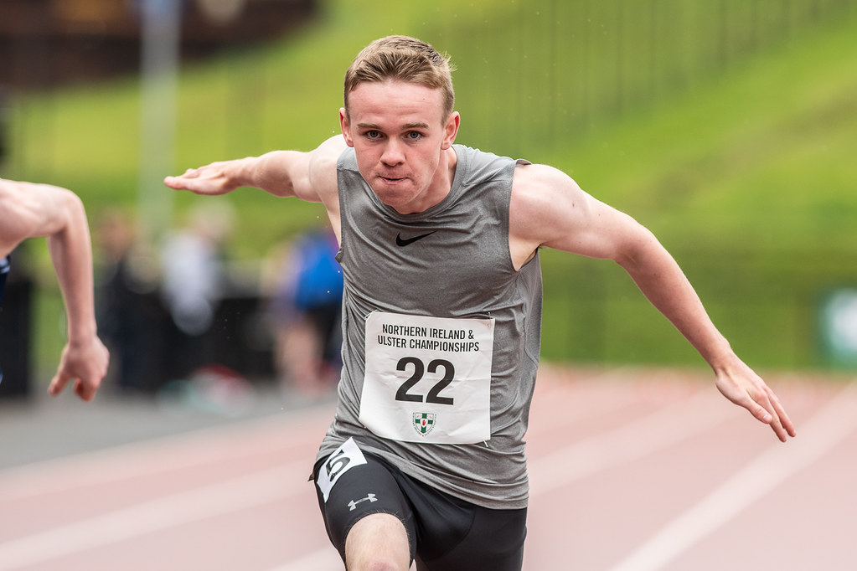

Application form

Please complete the following:

Name:
DOB:
School or University Year in September 2019:
Coach/Club (if any):
Home Town:
Weekly Training;
Normal Training Location:
Main event
2017 PB: date;
2018 PB: date;
2019 PB: date;

Secondary Event
2017 PB: date;
2018 PB: date;
2019 PB: date;

Spaces will be limited to allow us to meet ideal coach to athlete ratios and applications will be assessed based on performance, potential and availability to engage. Where an athlete already works with a jumps/sprints coach but wishes to supplement their normal training with this specialist session they should first speak to their coach about it. Coach-athlete pairs who would like to attend together to follow the training plan, upskill and benefit from working together in a group are welcome to apply.

After review of the applications there will be a selection process and successful applicants will be contacted. An offer will be made during September to allow for an October 2019 start. Once an offer is made to athletes, they will be able to assess that offer and their availability to attend at the proposed times before signing up to the online entry system to provide emergency contact details and make the session payments.

Applications may be typed or handwritten but must be either emailed to adam@thleticsni.org or alternatively posted to arrive by 6pm on 23rd September 2019 to:

Adam McMullen

Athletics House,

Old coach Road,

Belfast BT9 5PR

